Pickering Community Infant and Nursery School SEN information report

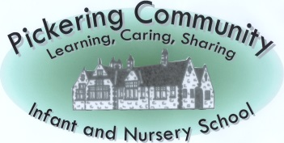
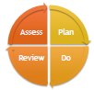
Pickering Community Infant and Nursery School SEN information report
Date November 2020

The North Yorkshire local offer can be found at:
http://www.northyorks.gov.uk/article/23542/SEND---local-offer

At Pickering Infant and Nursery School, we have high expectations of all children. We endeavour to create an atmosphere where every child can work to succeed and thrive. This document will explain the wide range of support we offer to ensure that children with special educational needs are able to fulfil their true potential. The purpose of this document is to provide clear and straightforward explanations of what we offer, using unambiguous language that families hopefully find useful. Where acronyms have been used, explanations are provided to give clarity. This document is updated at least annually and feedback from families will be sought in this timeframe to see how we can continue to improve our SEN provision.

Here are a list of the questions that will be addressed in this document:

1 What kinds of SEND are provided for in your school?
2 What policies do you have for identifying children and young people with SEND? How do you assess their needs? What is the SENDCo’s name and how can I contact them?
3 What arrangements do you have for consulting with parents of children with SEND and involving them in their child’s education?
4. What arrangements do you have in place in your school to consult with young people with SEND and how do you involve them in their education?
5. What arrangements are in place for assessing and reviewing children and young people’s progress towards outcomes. Please can you explain what opportunities are available to enable you to work with parents and young people as part of this assessment and review.
6. What are the arrangements for supporting children and young people in moving between phases of education and in preparing for adulthood? How do you ensure that as young people prepare for adulthood the desirable outcomes reflect their ambitions, which could include higher education, employment, independent living and participation in society
7. What is your School’s approach to teaching children and young people with SEND?
8. What sort of adaptations are made to the curriculum and the learning environment of children and young people with SEND?
9. What sort of expertise for supporting children and young people with SEND do you currently have in school? How do you ensure that the expertise and training of staff to support children and young people with SEND is current? How do you access and secure further specialist expertise?
10. How do you evaluate the effectiveness of the provision made for children and young people with SEND?
11. How are children and young people with SEND enabled to engage in activities available with children and young people in the school who do not have SEN?
12. How do you support children and young people with SEND to improve their emotional and social development? Please explain the extra pastoral support arrangements for listening to the views of children and young people with SEND and measures to prevent bullying.
13. How does the School involve other bodies, including health and social care bodies, local authority support services and voluntary sector organisations, in meeting children and young people’s SEND and supporting their families?
14. What are the arrangements for handling complaints from parents of children with SEND about the provision made at the school.
1 What kinds of SEND are provided for in your school?
This is North Yorkshire LA’s minimum expectations of good practice:
Children and young people (CYP) with a wide range of SEND are welcomed into the school. If a parent of a pupil with an EHCP requests a place at the school, the CYP is welcomed and strategies sought to meet needs.
This is what we provide in our school :
As a school, we pride ourselves on working with families (and where appropriate, outside agencies) to make reasonable adjustments so the individual needs of a child are met. We make provision for children with SEND within each of the four categories identified in the 2014 SEND Code of Practice:

Communication and Interaction: We have a number of pupils with speech, language and communication needs (SLCN). This may be because they have difficulty saying what they want to do, understanding what is being said to them or understanding/using social rules of communication. Children with autism or autistic type tendencies are likely to have particular difficulties with social interaction. They may also experience difficulties with language, commination and imagination, which can impact on how they relate to others.

The profile for every child with SLCN is different and their needs may change over times. Consequently, we employ a variety of ways to support children with SLCN including:

- Use visual timetables in all classes. Some children have individual visual timetables if required to support with transitions
- Use of Now and Next boards to prepare for a change of activity or step
- Use of the TEACCH approach to promote independent learning
- Comic Strip Conversations/Social Stories to promote understanding of social conventions and situations
- Use of Lego Play to support children’s social skills/listening and concentration
- We employ teaching assistants who support children with Speech and Language Difficulties in a 1-1 or small group setting as required.
- Support during unstructured times of the day i.e. Break and Lunch where required
- Small group or 1-1 support to develop social and emotional skills
- We have individualised Reward charts to support children's emotional and social needs
- Each class has access to Ipads and other ICT software to support different interests and preferred ways of learning.
- Access to regular, short sensory breaks (brain breaks)
- Where appropriate, school work with families to refer to the NHS Speech and Language Therapy team who will either provide universal guidance to support a child’s needs or offer a block of therapy and input. In either case, school work with guidance provided to ensure quality first teaching strategies are in place and/or provide a teaching assistant to deliver the activities in a structured 1:1 basis.

Cognition and Learning: Support for learning difficulties may be required when children learn at a different pace or in a different way than their peers, even with appropriate differentiation. As a school, we are experienced in supporting children with a wide range of Cognition and Learning needs including moderate learning difficulties (MLD) and complex learning difficulties (CLD), where children are likely to need support in all or most areas of the curriculum, both socially and emotionally, as well as academically. Children with complex and moderate learning difficulties are supported in a variety of ways, all designed to meet the unique needs of that learner in a personalised way, for example:
- by breaking down activities into smaller, achievable chunks
- providing appropriate resources including the use of technology or multisensory activities
- providing additional adult support
- pre-teaching opportunities
- giving additional time to process instructions
- key vocabulary displayed
- repetition and reinforcement of skills
- visual timetables, visual cues and prompts
- collaborative working opportunities
- a clear marking and feedback policy that allows children of all abilities to access it
- opportunities to access and record information in a variety of ways including the use of ICT
- structured phonics programmes
- multisensory approach to learning.
- We also run several interventions including the following evidence-based interventions; Readers Count, First Class @ Numbers and Talk Boost as well as other bespoke interventions to meet the needs of the children.

We also support a number of children with specific learning difficulties (SpLD), which affect one or more specific aspects of learning. This encompasses a range of conditions such as dyslexia (specific difficulties with reading or spelling), dyscalculia (specific difficulties with mathematics) and developmental coordination disorder. Here are some of the ways in which we can support a child with dyslexic type tendencies according to the needs of the child:
- Appropriate seating
- Visual timetabling
- Chunking instructions and giving more time for processing
- Dyslexia friendly handouts (clear font/readable size font/key information only)
- Dyslexia friendly classrooms
- Displays/writing on board – clear/uncluttered
- colour overlays for reading
- reading books suitable for children with dyslexia
- Individual spelling and writing prompts.
- We will also signpost parents to the appropriate private bodies that are able to provide an official dyslexia diagnosis should this be requested by parents. (Schools or statutory advisors are not able to make a formal diagnosis of dyslexia.)

Sensory and or physical: Some children require special educational provision because they have a disability which prevents or hinders them from making use of the educational facilities generally provided. These difficulties can be age related and may fluctuate over time. We have experience of working closely with outside agencies to provide support for children in our school who have sensory needs (vision impairment – VI, hearing impairment – HI, multi-sensory impairment MSI). We also have experience of working with children with a physical disability (PD), requiring on-going support and equipment to access all the opportunities available to their peers. Where necessary, we make adaptations to the curriculum or environment in order to make lessons and learning opportunities accessible to them. We hold regular meetings with outside agencies and parents to review the approaches that are in place. Here are some of the ways in which we support children with Sensory and Physical needs:
- Members of staff who deliver a range of fine and gross motor skill activities including delivering OT recommended programmes
- Our staff understand and apply the Medical Administration Policy
- All staff have received up to date First Aid training
- Careful consideration of preferential seating and position of teacher
- Disability awareness training for staff and children
- Pre-writing activities/warm up
- Letter formation and fine motor skills activities
- Modified resources eg large print and adaptations of resources and materials eg use of a writing slope

Social, mental and Emotional Health: At Pickering Infant and Nursery School, we pride ourselves on our pastoral care, and ultimately this is due to the strong commitment placed on children's personal and social development by our whole team of staff. We have experience of working with children with a wide range of social, emotional difficulties which manifest themselves in many ways. These may include becoming withdrawn or isolated, as well as displaying challenging, disruptive or disturbing behaviour. These behaviours may reflect underlying mental health difficulties such as anxiety, self-harming, or other symptoms that are otherwise medically unexplained. Other children have disorders such as attention deficit disorder, attention deficit hyperactive disorder or attachment disorder. We support these children through a variety of ways including social skills groups, 1:1 targeted support, personalised behaviour management plans, providing a personalised curriculum and personalised rewards and sanctions. Using the graduated approach to SEND, we also work closely with outside professionals and agencies such as Enhanced Mainstream Stream (EMS) Malton who support children with social, emotional and mental health barriers to learning, CAMHS (Child and Adolescent Mental Health Service), School Nurse, Health Visitors, Community Paediatrician and local authority Educational Psychologists if necessary. At Pickering Infant and Nursery School, we always seek to find ways to support the individual child whilst managing any disruptive behaviour so it does not adversely affect the learning of other children.

Here are some of the ways in which we support children with social/emotional barriers to learning:
- Our school’s behaviour policy focusses on positive behaviour management and encourages children to make the right choice
- We ensure that our behaviour policy can be adjusted and personalised to suit individual needs so that exclusions are kept to a minimum
- Personalising the curriculum to ensure work demands match the emotional stage of development of the child
- Additional support and alternative provision for children during unstructured times e.g. break and lunch
- Individual behaviour charts/reward systems where appropriate to suit individual needs
- Use of ‘The Incredible 5 Point Scale’ model; a discrete way to teach social and emotional awareness including self-regulation.
- We work closely with parents in a supportive role, to provide further strategies and ensure a consistent approach with children
- We have an appointed ELSA (Emotional Literacy Support Assistant) who delivers personalised interventions with small groups of children and/or 1:1 focusing on areas such as self-esteem, behaviour management, attachment and bereavement.

2 What policies do you have for identifying children and young people with SEN? How do you assess their needs? What is the SENCo’s name and how can I contact them?
This is North Yorkshire LA’s minimum expectations of good practice:
The name and contact number of the SENDCo should be readily available for parents. Where the school feels that something additional or different is needed to support your child because they have SEND they will discuss this carefully with you. This information may well be recorded in a document for you and your child, known as an individual provision map or an individual education plan. This should include:-
• details of any strategies being used to support your child in class;
• details of any extra support or interventions for your child
• your child’s learning targets and their long term desired outcomes
• the next date when your child’s progress will be reviewed.

Most pupils will benefit from SEND support, but some pupils who need high levels of support, or who have complex needs will need to be referred for an education, health and care plan.
This is what we provide in our school :
The attainment and progress of all children is carefully tracked and monitored throughout the school year by the class teachers and pupil progress meetings are held at least termly to review the provision that is in place. On a daily basis, teachers evaluate their lessons and consider whether individual children are making the expected progress and reflect on each child’s next steps. If teachers have any concerns regarding a child in their class, they will discuss these issues with parents and also with the SENDCo.
In line with the SEND Code of Practice, Pickering Infant and Nursery School offers a graduated approach to SEND:

Where a child is not making sufficient progress through the usual approaches to quality first teaching and learning, a meeting is held with class teacher and the family (and the SENDCo if applicable) to discuss and agree on ‘additional to’ or ‘different from ‘ strategies and interventions. Where concerns remain, the child may be added to the SEND Register at the ‘SEND support’ level so that their progress can be closely monitored and additional support can be put in place as necessary. Parents are always informed at this stage. Most needs in relation to SEND can be met within mainstream settings out of schools own resources. If however little or no progress is made through the ‘assess, plan, do, review’ approach, the SENDCo would liaise with the relevant outside agencies. This would determine whether any further formal assessments need to be carried out in order to identify key areas to target and to evaluate the effectiveness of any interventions that are put in place.

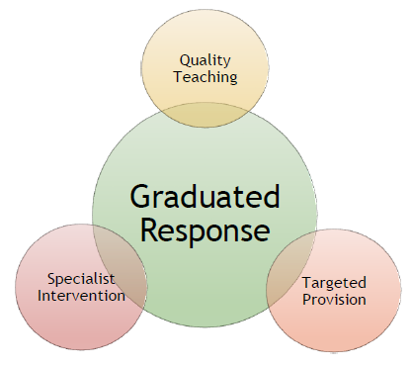
Where a child with SEND continues to make little or no progress over time, even with the support of external specialists, the school will then consider asking the local authority to undertake a statutory assessment of the child’s SEND, through a request for an education, health and care needs assessment (EHCAR). The school SENDCo has strong working knowledge of the EHCP process and will work closely with families and class teacher throughout this journey to make sure they are aware of next steps. A successful application is contingent upon evidencing the support provided through the school’s SEND provision over time, including external support and advice. There should also be evidence that that the child has severe and complex needs that cannot be met within the resources ordinarily available to school. Please note, once this has been submitted however, it does not necessarily lead to assessment and an education health care plan.
How we record SEND provision with our families:
At Pickering Infant and Nursery School, in July 2017, the SENDCo conducted an audit of SEND provision. As a result we have redesigned the way in which we record and monitor SEND provision, ensuring that discussion is held with the family about the following:
- details of any extra support or interventions for your child
- details of any strategies being used to support your child in class;
• your child’s learning targets and their long term desired outcomes

At Pickering Infant and Nursery School, Miss Corton, Interim SENDCo, works closely with the Senior Leadership Team and is available to meet families to discuss provision and any concerns. If you ever need to speak to Miss Corton, then please either speak to a member of the office team or phone school to leave a message, which Miss Corton will respond to as soon as possible.

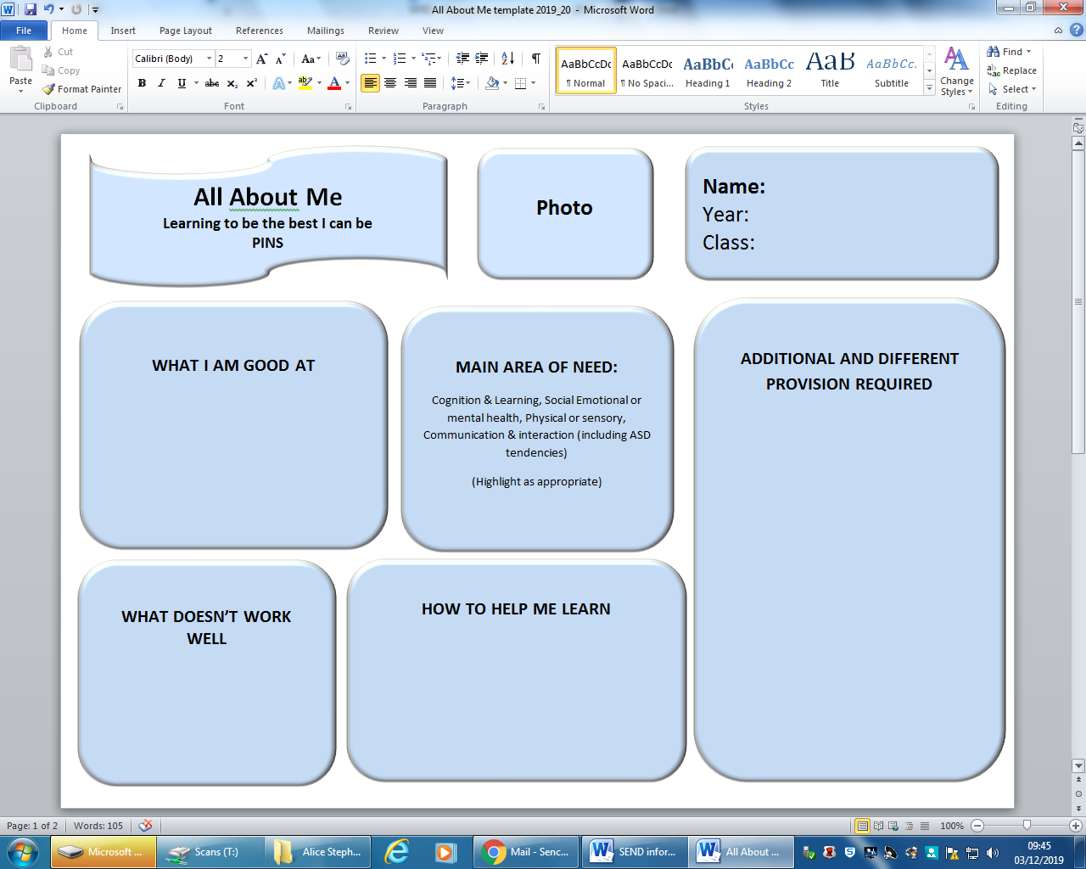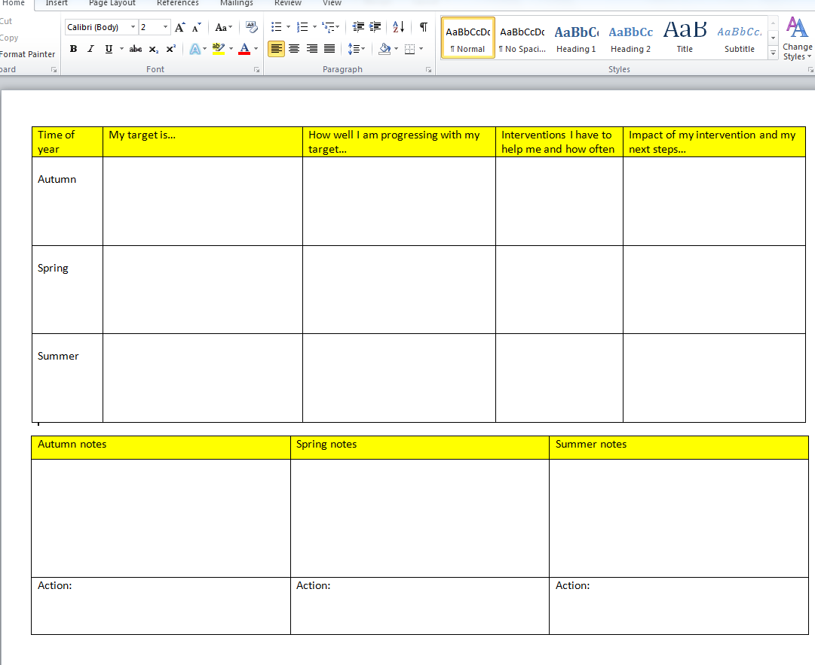

3 What arrangements do you have for consulting with parents of children with SEN and involving them in their child’s education?
This is North Yorkshire LA’s minimum expectations of good practice:
Schools communicate regularly with parents, usually once a term, to discuss how well their child is doing. They listen to what parents have to say and respond to it. For pupils with SEND it is often desirable that there is more frequent communication as it is vital that parents and school work together closely. Your knowledge and understanding of your child’s needs is essential to support the school in making the best provision for them. This should also take account of your and your child’s hopes, personal goals and interests.
This will allow the school to regularly explain to you where your child is in their learning, and to work with you to ensure the most appropriate targets are set to ensure progress.
On-going communication with school may include:
• regular contact through a home-school book or by e-mail to keep you informed of things that are going well or particular successes
• more regular meetings to update you on your child’s progress and whether the support is working
• clear information about the impact of any interventions
• guidance for you to support your child’s learning at home.
This is what we provide in our school :
Recording SEND provision: as parents, we are aware that you know your children best and therefore we encourage a close working partnership so that you and your children have a happy and productive journey throughout your time in our school. As such, at Pickering Infant and Nursery School, we go to great lengths to facilitate an environment where the voice of the child and the family is at the heart of what we do. Consequently, after a recent audit of SEND, all children with identified additional needs now have an ‘All About Me’, where individual SEND provision is recorded, monitored and reviewed. The class teacher meets with the family at least termly to discuss and review provision as well as agreeing next step and new targets. In the ‘All About Me’ process, all parent/carers and children feed their voice and opinion into the process.

Interventions: when a child is identified as being suitable for intervention, we communicate with parents, letting them know the focus of the intervention as well as who is running it. All children receiving a structured intervention will be pre and post tested to monitor impact and parents are informed of progress made as well as next steps.

Flexible communication: as a school, we strive to ensure a high level of communication with parents so you feel well informed about what is happening in school and how well your child is progressing. We have an ‘open door policy’ and teachers are always happy to meet with parents at a mutually convenient time. We strongly encourage parents to communicate any concerns with us as and when they arise. We also offer parent termly SEND consultation meetings, and of course there are open evenings and annual reports. We operate a school text messaging service which informs parents of events. The school publishes a newsletter for parents detailing forthcoming news and celebrating the successes of children. We aim to meet with parents of children with SEND as they join our school. For children with Educational Health Care Plans, parents will be invited to attend their Annual Review meeting in which children’s progress against their individual targets is looked at in detail and decisions about future provision is jointly agreed.
4. What arrangements do you have in place in your school to consult with young people with SEN and how do you involve them in their education?
This is North Yorkshire LA’s minimum expectations of good practice:
School will obtain the views of all children (pupil voice) to shape provision in school. Your child’s school may have a school council. In addition, it is vital that the views and aspirations of children and young people with SEND are listened to and they are supported to achieve their aspirations as far as possible. You school will be able to describe how this is undertaken and the frequency with which the child is consulted.
This is what we provide in our school :
Involving a child in their education is at the heart of our learning at Pickering Infant and Nursery School. All children are actively involved in their own marking feedback where they assess their own learning as well as working with the teacher to respond to marking feedback. This is differentiated to be accessible to all our children including those with additional needs. As part of the ‘All About Me’ process, the class teacher elicits pupil voice at least termly exploring the following points:

- What the child thinks they are good at doing.
- What the child thinks helps them to learn.
- What doesn’t work well for the child.

When supporting children with SEND, we aim to talk to our children and fully involve them in the process. We discuss their individual targets and progress with them and make sure we celebrate their achievements with them, however big or small. For children with an Educational Health Care Plan those views may be discussed with them before the meeting or if appropriate, children can come into the meetings to share their views. We use a range of practical and visual strategies to support children who find it difficult to express their views with words. Wherever possible, we try to take into account the views, wishes and aspirations of our pupils when discussing outcomes for the child and approaches to achieve them.

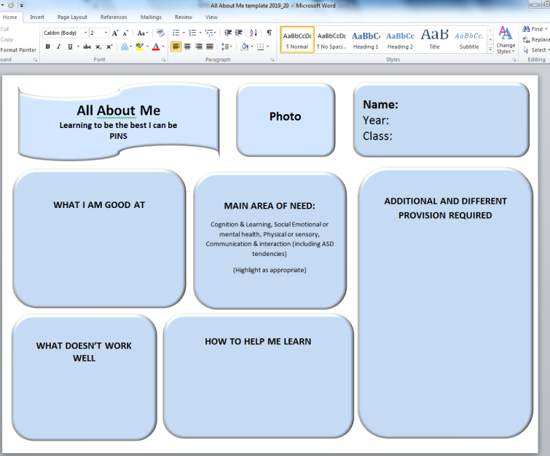

5. What arrangements are in place for assessing and reviewing children and young people’s progress towards outcomes. Please can you explain what opportunities are available to enable you to work with parents and young people as part of this assessment and review
This is North Yorkshire LA’s minimum expectations of good practice:
All pupils with SEND should make at least expected progress, in line with their peers. Your school will be able to explain how it will be monitoring your child’s progress to ensure that it is at least in line with expectations. This will usually include progress made with personal targets, and overall progress on the National Curriculum.
Many schools use inclusion passports. This is a document that summarises the support that has been given to a pupil over a period of time, and the difference that this support has made. You may like to ask your child’s school whether an inclusion passport would be useful for you and your child. Your child may well have their own version which they can share with staff and which can help to explain their interests and things that help them learn and to enjoy school.
This is what we provide in our school :
We are frequently assessing pupils’ progress through Teacher Assessment. The children are then more formally assessed termly and their progress is recorded allowing us to analyse the data in greater detail. Progress of all children is reviewed regularly to make sure that they are making at least expected progress. Parents/carers have the opportunity to discuss their child’s progress at SEND termly review meetings. We expect Pupils on the SEND register to make the same progress in line with their like for like peers. Each term, children’s targets and progress is shared and reviewed at their ‘All About Me’ meeting. As well as academic targets, targets are also agreed for children in relation to their particular barrier to learning. These targets are reviewed regularly, where outcomes are discussed as well as next steps and new targets agreed.
In KS1, where a child is still accessing the Early Years Curriculum rather than KS1 national curriculum, the school will currently use P Scales to access and plan small next steps of learning for your child. In this situation, the use of P Scales is statutory for reporting teacher assessment in literacy, mathematics and science to the Department for Education at the end of Key Stage 1. The school will continue to follow statutory guidance with regards to the future use of P scales.
6. What are the arrangements for supporting children and young people in moving between phases of education and in preparing for adulthood? How do you ensure that as young people prepare for adulthood the desirable outcomes reflect their ambitions, which could include higher education, employment, independent living and participation in society
This is North Yorkshire LA’s minimum expectations of good practice:
Your SENDCo should arrange an appropriate transition review in plenty of time before any move. Staff from the receiving school should be invited to attend. Transition meetings and visits should be arranged for the pupil or student, often accompanied by a well-known member of staff. The pupil should receive as much transition work as they feel necessary.
This is what we provide in our school :
KS1/KS2 Transition: Miss Corton is Interim SENDCo at Pickering Infant and Nursery School and works closely with the Interim SENDCo at Pickering Community Junior School, our main feeder school. Mrs Sealy, as SENDCo, shares her role across both sites. As such, we have a structured and effective transition programme to support children as they move between classes or key stages within the school and between schools. There is an extremely strong emphasis placed on transition between KS1 and KS2. If required, children are given additional opportunities to visit their new school, as well as meetings held with new class teachers where relevant. In the summer term, children with additional needs are able to meet with their new KS2 teacher. When children meet their new class teachers, they are given the opportunity of discussing their thoughts about schooling using their ‘All About Me’ as a prompt. This ensures we are well informed about your child’s additional needs and can plan appropriate provision for the forthcoming year.

Moving to a new school: if a child with SEND is joining our school part-way through their school career/school year, we will arrange for parents to meet with the SENDCo and/or Headteacher to discuss the child’s needs. We will also liaise with the child’s previous school to discuss strategies and support that have been effective in the past. If necessary, we can arrange extra visits to support your child’s transition to us.

Moving classes: Current and receiving teachers are given allocated times to meet and share information about each child, including effective approaches and strategies for meeting the needs of children with SEND. All children are given the opportunity to spend time with their new class teacher in the summer term. Where necessary, children with SEND make extra visits to their new classroom, are supported by social stories to prepare them for the changes ahead and are given photo-books of their new classroom, teacher and any other adults that will be supporting them.
7. What is your School’s approach to teaching children and young people with SEN?
This is North Yorkshire LA’s minimum expectations of good practice:
High quality support for learning within mainstream lessons is the most important factor in helping pupils with SEND to make good progress alongside their peers. There may be occasions when the school feels that some additional support within lessons may help your child to make better progress. This is by no means always the case. However, if some additional small group or one to one support within lessons is planned, the school will explain how this will work, what the aims of this support will be and how and when the impact of this support will be reviewed. Most importantly, this support should be aiming to make your child more independent in lessons
Schools use a range of evidence based interventions to support pupils with SEND to make better progress. Interventions are structured learning programmes. Your school will be able to explain to you:
• what interventions your child is receiving and what are the intended learning outcomes;
• when during the week any interventions will be delivered and for how many weeks;
• who will be delivering the interventions (usually a well trained teaching assistant) and where (e.g. in class or outside the classroom)
• how the interventions will relate to and support learning in the classroom;
• how they will be monitored closely to make sure they are helping your child to make accelerated progress.
This is what we provide in our school :
We provide an inclusive learning environment where all children, including children with SEND are treated equally and have access to the full range of opportunities that we provide. For some activities, children are grouped according to ability but we also ensure that pupils are provided with the opportunity to work with children of all abilities within their class throughout the year. Teachers differentiate learning to meet a variety of different needs and children are encouraged to reflect upon their own progress and are fully involved in the process of selecting learning that matches their own learning needs. Our approach is to tailor learning opportunities so that they are accessible to all the children through effective planning and differentiation of lessons. We aim to provide stimulating and exciting learning experiences that all children can access at their individual levels. The high expectations and aspirations that we have for all children in the school are extended to children with SEND. Children with SEND and disabilities are fully included in activities throughout the school day. If necessary, we provide additional support to enable this to happen, for example ‘meet and greets’ in the morning, additional support at playtimes or lunchtimes or for extra-curricular activities, including school trips.

Interventions: we also run a number of interventions including the following evidence-based interventions; Readers Count, First Class @ Numbers and Talk Boost as well as other bespoke interventions to meet the needs of the children. All our interventions are run by skilled and well trained Teaching Assistants. If school is suggesting a child receives intervention, this is discussed with the family to confirm the details such as timings, focus, outcomes, who will lead the intervention, how it will be monitored to ensure accelerated progress, and importantly, how it relates to support learning in the classroom. Feedback is provided at the end of an intervention.
8. What sort of adaptations are made to the curriculum and the learning environment of children and young people with SEN?
This is North Yorkshire LA’s minimum expectations of good practice:
Your school will be able to describe some of the approaches that classroom teachers and other staff will be using throughout the day to help address your child’s needs within lessons. They may also be able to share with you the school’s overall plan of support (provision map), which outlines many of these strategies.
Some children with a high level of need will also need a care plan or a health care plan which may include a risk assessment.
This is what we provide in our school :
The SEND Code of Practice (2014) recognises that ‘Special Educational Provision is underpinned by high quality teaching and is compromised by anything less’. Our priority is to ensure that all children, including children with SEND have access to good or outstanding lessons which are appropriately differentiated and personalised to meet the needs of individual children. We also recognise that some children will require educational provision that is ‘additional to’ or ‘different from’ this. To achieve this, we engage in a cyclical four-stage process: ‘Assess, Plan, Do and Review’

- Assess: The class teachers and if necessary the SENDCo or professionals from external agencies, assess the needs of the individuals.
- Plan: We identify the barriers to learning, intended outcomes and plan appropriate support and intervention to meet those outcomes.
- Do: We provide appropriate support either within the classroom or as part of a targeted intervention programme. This could involve the provision of a resource, a change in an approach to learning, access to technology or working with an adult.
- Review: We evaluate the impact of the support provided and consider whether changes to the support need to be made.
A small number of children may require specific adaptations to the learning environment. Examples include the provision of modified equipment, individual workstations, picture cards, sensory equipment (e.g. sensory stories) etc. Through consultations with teachers, TAs, parents and children, the SENDCo makes decisions regarding the most effective allocation of resources in order to most effectively meet the needs of the children with SEND within the school. This includes physical and human resources. Teaching Assistants are allocated carefully according to their skills and experience, in line with the needs of the children, with many Teaching Assistants becoming specialised in certain areas such as reading or with certain interventions.
9. What sort of expertise for supporting children and young people with SEN do you currently have in school? How do you ensure that the expertise and training of staff to support children and young people with SEN is current? How do you access and secure further specialist expertise?
This is North Yorkshire LA’s minimum expectations of good practice:
All staff should receive regular training to enable them to meet a range of SEN. Teachers and teaching assistants should have regular generic training and specific training to meet individual needs as necessary.
Schools must make good use of their SEN funding to meet a range of need. However, if a pupil has particular needs and the school has exhausted its repertoire, specialist support should be sought promptly.
This is what we provide in our school :
Miss Corton is currently completing her Post Graduate National SENDCo award which is a requirement for all SENDCo’s to obtain within their first three years in role. She also regularly attends North Yorkshire SENCO meetings to update on new policies and procedures. Mrs Sealy has already obtained her NASENCO qualification and has 10 years of experience working in the education sector, before her maternity leave, Mrs Sealy delivered in-depth CPD to all staff around dyslexia and dyslexia friendly classrooms. All staff are given the opportunity and encouraged to continue their professional development in SEND areas. Where necessary, staff will undertake specific training in an area of immediate need or seek advice from outside agencies and professionals. Teaching Assistants also receive continuous professional development in line with emerging needs and priorities of the school.
10. How do you evaluate the effectiveness of the provision made for children and young people with SEN?
This is North Yorkshire LA’s minimum expectations of good practice:
The progress and attainment of all children is carefully monitored and reported to parents. Your school will be able to explain how they track pupil progress in their school. If a child is provided with additional and different provision/interventions, the school will carefully monitor the impact by a variety of methods; such as: measuring how the intervention accelerated progress over a given time – known as a ratio gain or the before and after impact on self-confidence, behaviour etc. During the planning meeting with parents and where possible the child or young person, the teacher will explain what the expected impact will be by the time the intervention is reviewed and how this will be measured. Many schools use Individual Provision Maps (IPMs) to capture this information, which is written during your meeting. This meeting with you and your child is often described as a ‘learning conversation’.
The school will evaluate the impact of all interventions and whether they have a strong evidence base of effectiveness.
Other provision, for example provision regularly used in-class (known as Quality First Teaching), will be evaluated regularly by the Senior Leadership Team. Your school will be able to describe how this is undertaken.
We have a robust system of self-evaluation in which we evaluate all areas of school’s effectiveness including that of SEND. The SENDCO and SEND governor meet to discuss the provision for children with SEND. The Governors also receive regular reports. Each term, the performance data of children with SEND is analysed by SLT and areas of need are identified. In addition, interventions are regularly reviewed and monitored to ensure that the impact is effective.
11. How are children and young people with SEND enabled to engage in activities available with children and young people in the school who do not have SEN?
This is North Yorkshire LA’s minimum expectations of good practice:
The school’s policies should all state how all pupils are actively included in a wide range of curriculum and extra-curricular activities, including school trips. Pupils with SEN should be equally represented in positions of responsibility e.g. the school council.
This is what we provide in our school :
We provide, for all children, a broad, balanced and relevant curriculum and we work to overcome the barriers to learning, so that all children are able to make good progress. We aim to make sure children with SEND are fully involved in the life of the classroom and work with their peers. For children with complex learning needs who have 1-1 TAs support, their statutory or recommended tailored provision may require short, highly personalised 1:1 learning opportunities. We recognise that progress encompasses aspects of academic attainment, personal and social development and independence and that all progress should be celebrated. All children are given the equal access to participate in school activities and are supported throughout their time at school to achieve the best that they can whatever level they are working at. Through the use of pupil and parent voice, teachers prioritise SEND children for clubs and roles of responsibility where relevant.
12. How do you support children and young people with SEN to improve their emotional and social development? Please explain the extra pastoral support arrangements for listening to the views of children and young people with SEN and measures to prevent bullying.
This is North Yorkshire LA’s minimum expectations of good practice:
Some of the interventions implemented should be for emotional support e.g. SEAL nurture groups, the provision of a key worker.
This is what we provide in our school :
Training on medical needs is provided through first aid training. Any extra requirements for specific medical needs would also receive training. Relevant healthcare professionals provide support to the school as and when required. Through assemblies, topics such as bullying, e-safety and abuse are sensitively and appropriately discussed. In addition to this, our school staff are skilled in dealing with pupils who require additional emotional support through the use of social skills intervention such as Lego play, the Incredible 5 point scale and 1:1 support. We also have an appointed and trained member of staff who is our Emotional Literacy Support Assistant (ELSA) who delivers personalised small group and/or 1:1 sessions that can focus on developing self-esteem, behaviour management, attachment, circle time and bereavement. We have a whole school behaviour management system which promotes social and emotional development. The school provides opportunities in the curriculum through PSHCE to discuss and teach about difficult issues that children may face in today’s World. They approach this in an open manner and all children are encouraged to talk about anything they feel uncomfortable about be this privately or in a class situation.
13. How does the School involve other bodies, including health and social care bodies, local authority support services and voluntary sector organisations, in meeting children and young people’s SEN and supporting their families?
This is North Yorkshire LA’s minimum expectations of good practice:
The Local Authority offers a range of specialist support and outreach services, including educational psychologists and local enhanced mainstream schools, to help schools to deliver appropriate support and interventions, Other specialists such as speech and language therapists can also support schools in this. If the school feels that the involvement of another agency will help them to meet your child’s needs you will be informed and asked to give your consent.
This is what we provide in our school :
We have extremely strong links with a range of education, health and social care professionals who can support the process of assessment, target-setting and ensuring that the needs of children with SEND are appropriately met. The school uses the single point of contact and staff understand how to make referrals using this if they have any concerns. The school work alongside: - Local Enhanced Mainstream Schools for Moderate Learning Difficulties, Communication & interaction (including Autism support) and Social, Emotional and Mental Health as well as the NHS Speech and Language service, Educational Psychologist and CAMHS.
14. What are the arrangements for handling complaints from parents of children with SEN about the provision made at the school.
This is North Yorkshire LA’s minimum expectations of good practice:
There must be a designated governor for SEN in the school and complaints about SEN should follow the general complaints procedure. It is always best to approach the teacher or the Headteacher first, to see if your concerns can be immediately addressed. If you still feel that your view has not been listened to or answered to your satisfaction you can make a formal complaint by writing to the chair of governors at the school.
This is what we provide in our school :
Our complaints procedure relating to SEND is the same procedure for the whole school. The full policy can be read on the school website. In the first instance the concern should be brought to the attention of the class teacher or Interim SENDCo (Miss Corton) who may be able to resolve it. If this is not possible, the issue would be escalated to the Headteacher. If the complaint still cannot be resolved a complaints form must be completed and sent to the chair of governors Mr Herring.

Our SEND linked governor is Mrs Challiss

Details of the school’s complaints procedure can be found on our school website.

